**2190151 Computer Programming Lab**

Lab 5: Weather Station

Objectives:

1. Student be able to use simple sensor in their IoT project

2. Student be able to write graphical display of data on M5Stack

3. Student be able to create Hygrometer, Temp Clock

**Background Theory**

The DHT11Temperature & Humidity Sensor features a temperature& humidity sensor complex with a calibrated digital signal output. By using the exclusive digital-signal-acquisition technique and temperature & humidity sensing technology, it ensures high reliability and excellent long-term stability. This sensor includes a resistive-type humidity measurement component and an NTC temperature measurement component, and connects to a high performance 8-bit microcontroller, offering excellent quality, fast response, anti-interference ability and cost-effectiveness.

**Task1: Basic weather station**  
**Step 1. Go to the folder Arduino-ESP32-IDE and open the app arduino.exe (Fig. 1);**

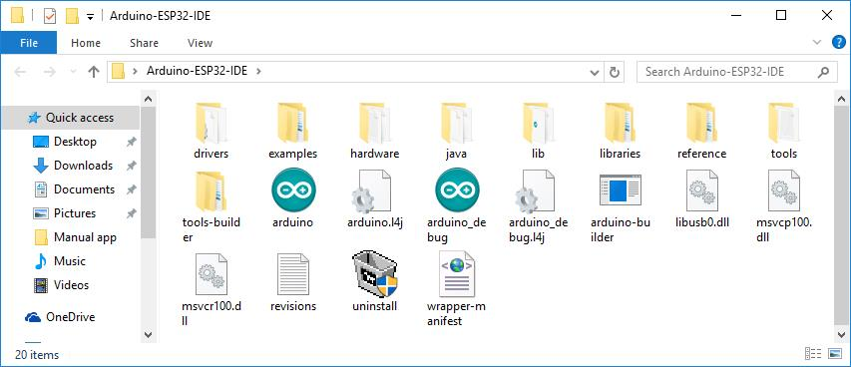  
Figure 1. The archive with the Arduino IDE extracted to the folder

**Step 2. Select New in the File menu (Fig. 1.1);**

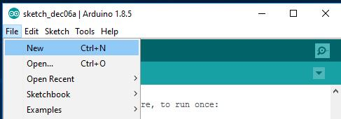  
Figure 1.1. Create a new sketch

**Step 3.1. Select Include Library->manage Libraries, in the Sketch menu and search for Simple DHT library and install (Fig. 1.2);**

A screenshot of a cell phone


**Step 3.1. Select Include Library->manage Libraries, in the Sketch menu and search and install M5Stack library and M5Stack-SD-Updater(Fig. 1.3);**

**A screenshot of a social media post

**

**Step 3.3. Select Include Library, M5Stack in the Sketch menu (Fig. 1.4);**

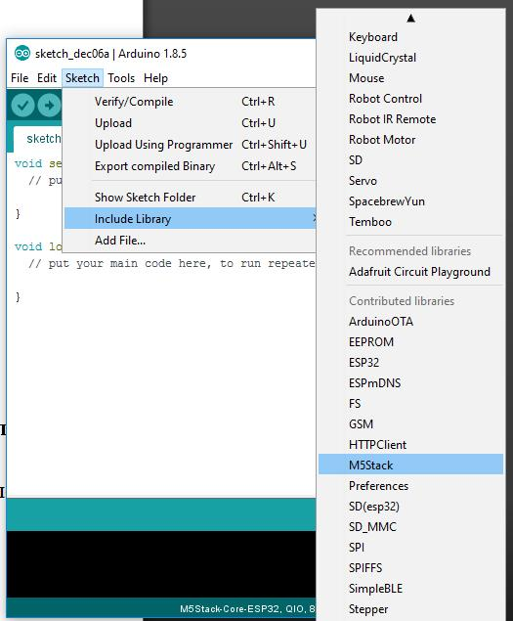  
Figure 1.4. Connection library M5Stack

**Step 4. Prepare the temperature sensor and humidity DHT11 (Fig. 2), Using a diagram in Figure 2.1 connecting DHT11 module, positive pin to 5V , negative pin to GND and data pin (middle) directly to port 5 of M5Stack ( pull up resister are provided in the module)**

A circuit board

Figure 2. Temperature sensor and humidity DHT11

A screenshot of a cell phone


Figure 2.1 Connecting sensor to MCU (M5Stack)

**Step 5. Write a simple sketch, which main task will be the output temperature in degrees Celsius on the display (if 27 and below, green if above, red color) (Fig. 3);**

Figure 3. Our sketch

#include <M5stack.h>

#include <SimpleDHT.h>

#include <Wire.h>

#define DHTPIN 5

SimpleDHT11 dht;

int temperature, humidity;

int old_t = -1000;

void setup(){

M5.begin();

Wire.begin();

M5.Lcd.setTextSize(10);

}

void loop() {

float temp,humid;

int status = dht.read2(DHTPIN, &temp, &humid, NULL);

if (status == SimpleDHTErrSuccess) {

temperature = temp;

humidity = humid;

}

if (temperature != old_t){

if (temp > 27){

M5.Lcd.setTextColor(0xe8e4);

}

else{

M5.Lcd.setTextColor(0x2589);

}

M5.Lcd.fillScreen(0);

M5.Lcd.setCursor(0,0);

M5.Lcd.print(temperature);

M5.Lcd.print(“ C”);

}

old_t = temperature;

M5.update();

}

**Step 5. Click the Upload button (Fig. 4) in order to flash the device;**

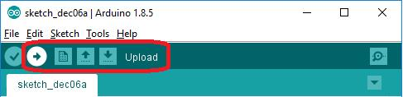  
Figure 4. Download the firmware to the device

**Step 6. When the device firmware is completed, the screen will display the temperature (Fig. 5, 5.1) :)**



Figure 5. Temperature 24 and 28 degrees Celsius

**Task 2: Celcius Temp/ Hygrometer**

Make a sketch to display both temperature and humidity including their unit on M5stack Lcd screen

**Task 3: Fahrenheit Celcius Temp/ Hygrometer**

Make a sketch to display both temperature and humidity including their unit on M5stack Lcd screen and the temperature unit shown can be changed by pushing button A.

**Task 4: Hygrometer, Temp Clock**

Make a sketch to display Hygrometer Celcius Temp Clock, where the temperature unit can be changed by button A, and the clock display mode (0-12 or 0-24) can be changed by pushing button B.

**Section_____________date__________**

**Name____________________Student ID______________**

**Laboratory 4 Weather Station:**

**Task1: Basic weather station**

Graded by _____________________Time________________

**Task 2: Celcius Temp/ Hygrometer**

Graded by _____________________Time________________

**Task 3: Fahrenheit Celcius Temp/ Hygrometer**

Graded by _____________________Time________________

**Task 4 :Hygrometer, Temp Clock**

Graded by _____________________Time________________

**What do you learn from this lab?**